ME 231 Fluid Mechanics · Test #2 (Mon 11/9)
Homework Collection
Every problem assigned since Test #1 · White & Xue, Fluid Mechanics 9th ed.
Due | Topic | Problems
Wed 10/14 | Differential relations (Ch 4) | 4.1, 4.4, 4.9, 4.47, 4.51, 4.59, 4.27, 4.34
Mon 10/19 | Bernoulli (Ch 3) | 3.114, 3.124, 3.127
Mon 10/26 | Dimensional analysis (Ch 5) | 5.24, 5.31, 5.37, 5.72, 5.73, 5.74
Mon 11/2 | Pipe flow (Ch 6) | 6.4, 6.8, 6.18, 6.19, 6.43
Wed 11/4 | Pipe flow (Ch 6) | 6.52, 6.55 (+ 6.103, 6.124: not in the uploaded pages)

One problem per page, in syllabus order. Re-work each one cold on the grid below it, then compare with your graded copy. Your professor wrote and graded these, so they are the closest preview of the test.
P6.103 and P6.124 (due 11/4) are on book pages after 440, past the end of the uploaded PDF, so they are not included.

P4.1 · HW due Wed 10/14 · Differential relations (Ch 4)
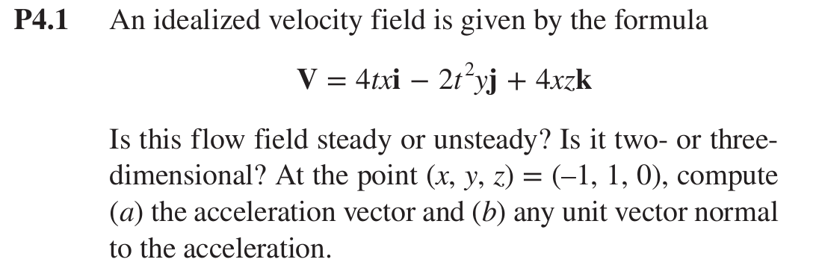

P4.4 · HW due Wed 10/14 · Differential relations (Ch 4)
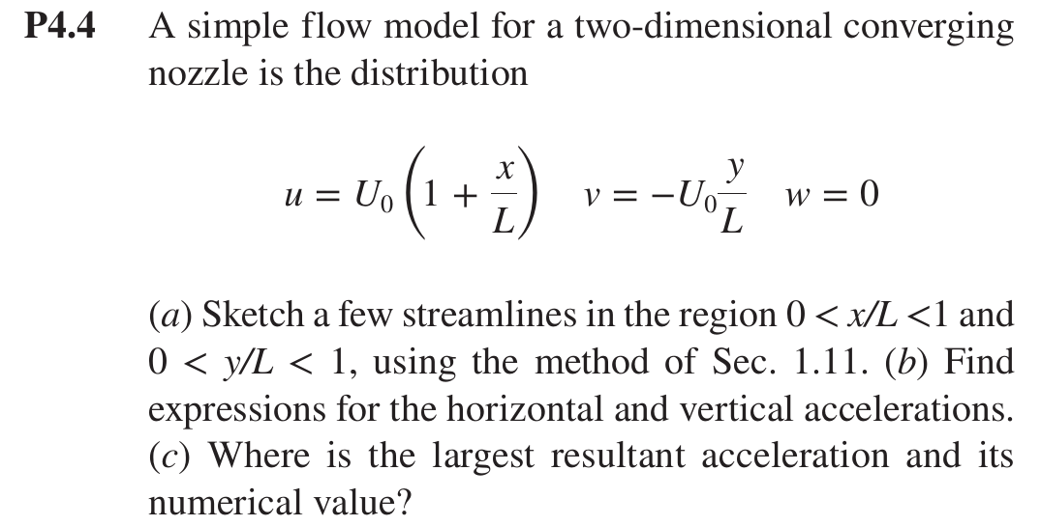

P4.9 · HW due Wed 10/14 · Differential relations (Ch 4)
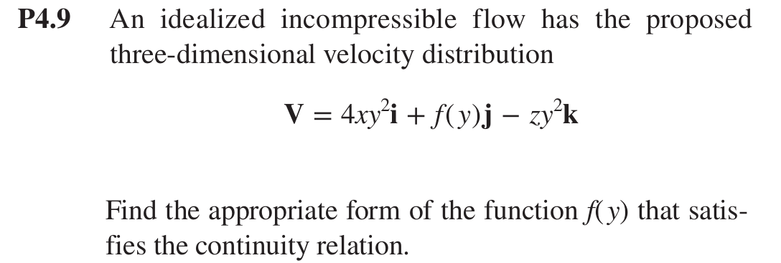

P4.47 · HW due Wed 10/14 · Differential relations (Ch 4)
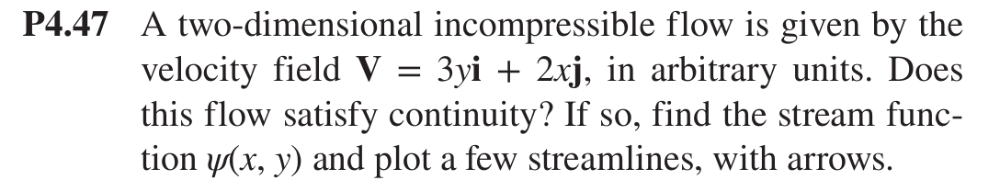

P4.51 · HW due Wed 10/14 · Differential relations (Ch 4)
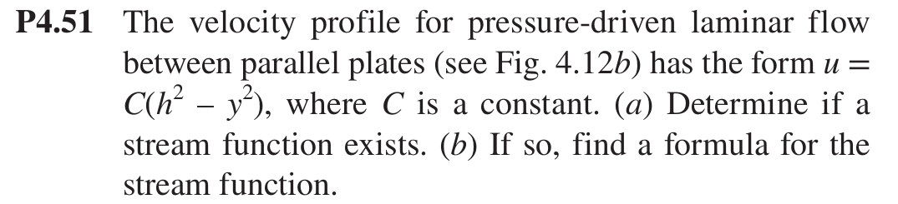

P4.59 · HW due Wed 10/14 · Differential relations (Ch 4)
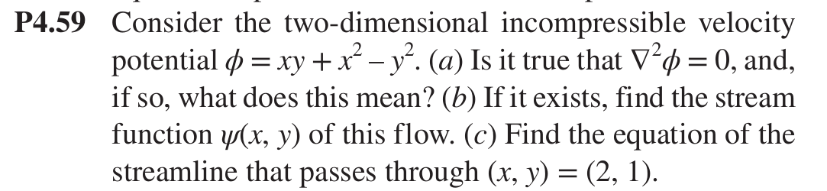

P4.27 · HW due Wed 10/14 · Differential relations (Ch 4)
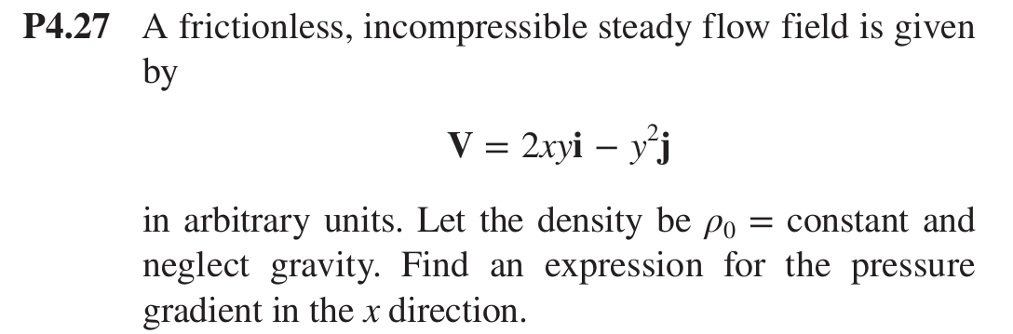

P4.34 · HW due Wed 10/14 · Differential relations (Ch 4)
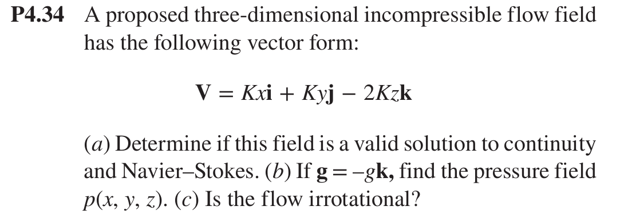

P3.114 · HW due Mon 10/19 · Bernoulli (Ch 3)
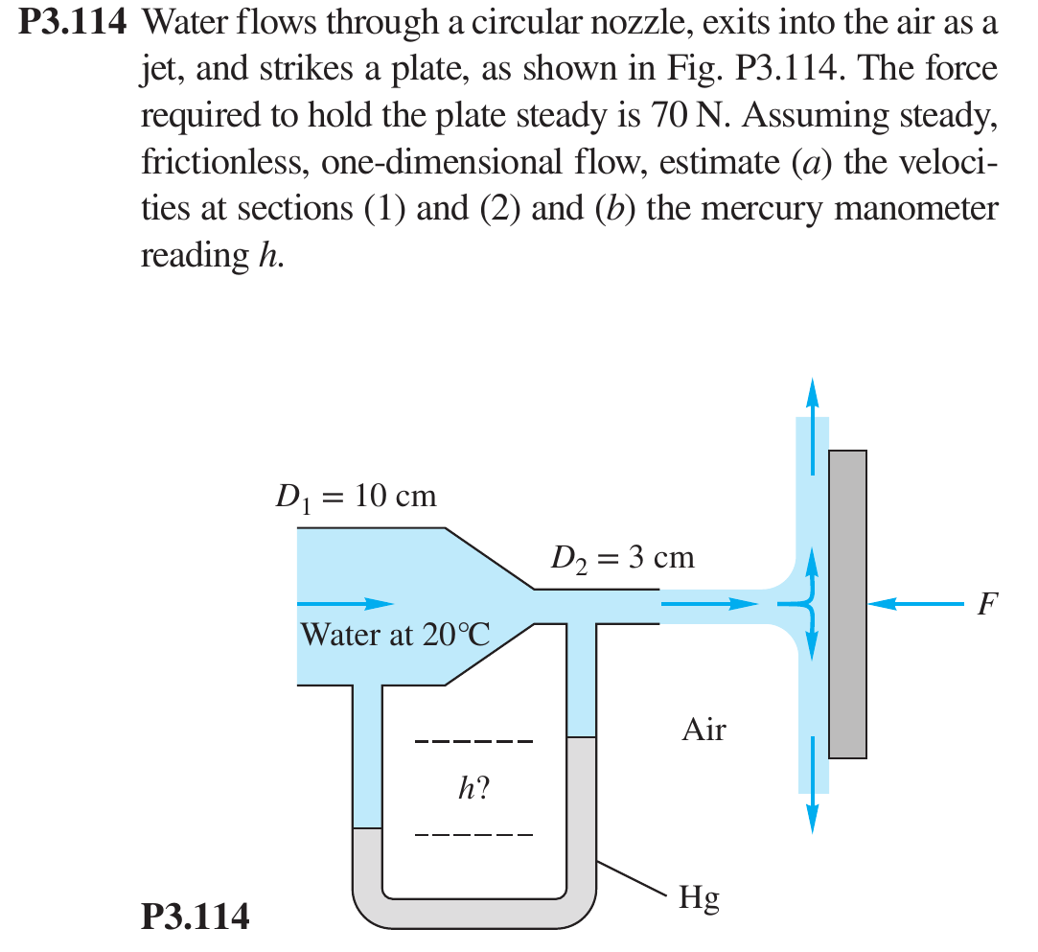

P3.124 · HW due Mon 10/19 · Bernoulli (Ch 3)
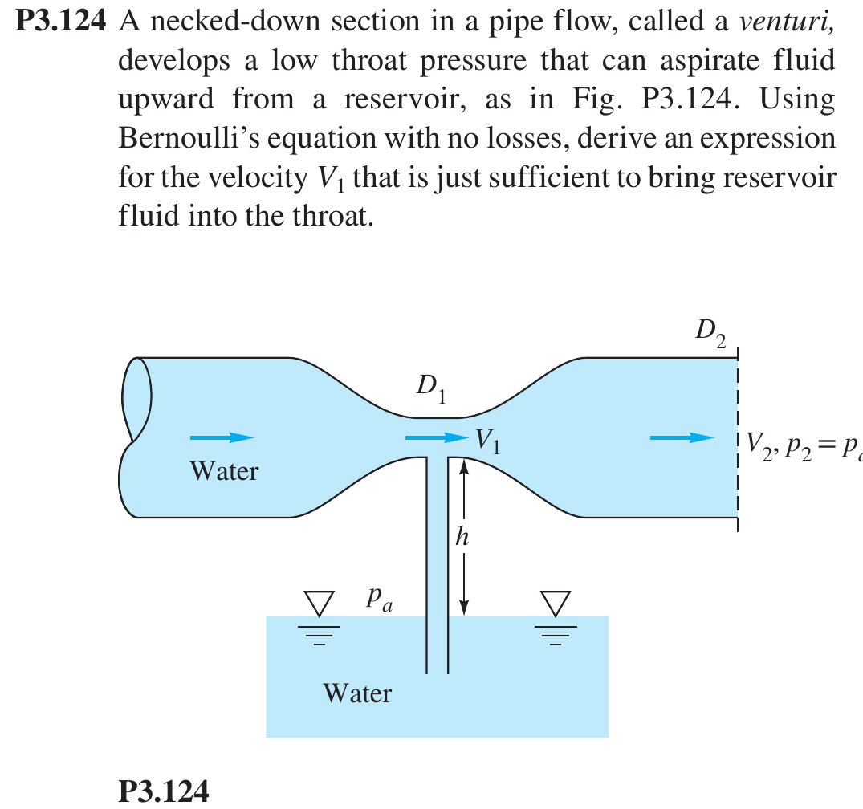

P3.127 · HW due Mon 10/19 · Bernoulli (Ch 3)
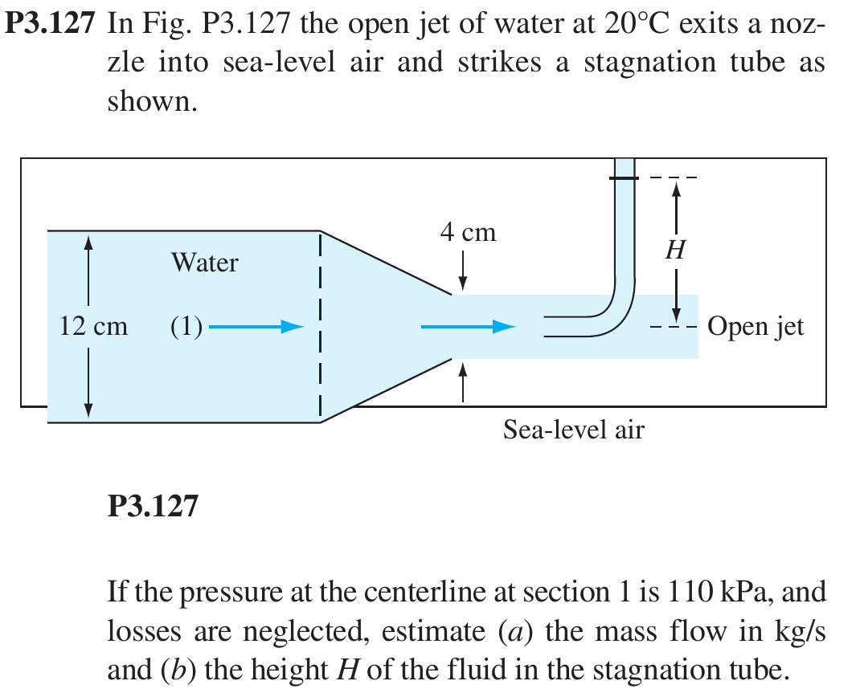

P5.24 · HW due Mon 10/26 · Dimensional analysis (Ch 5)
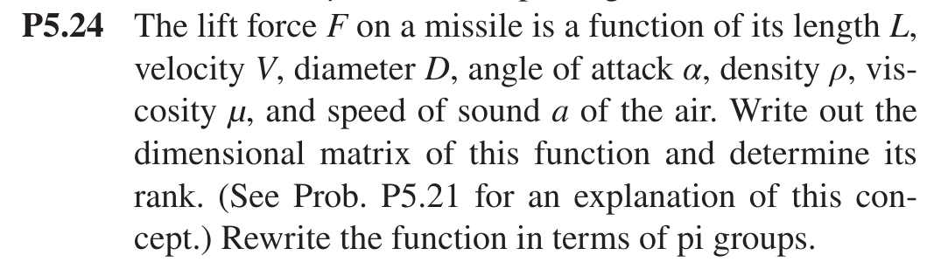

P5.31 · HW due Mon 10/26 · Dimensional analysis (Ch 5)
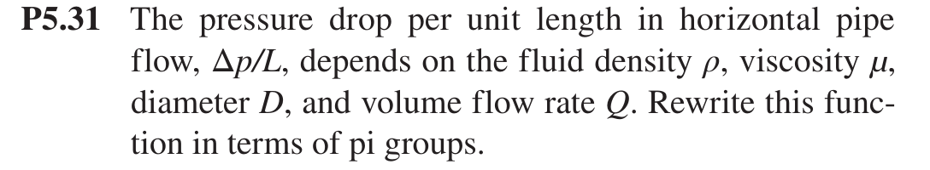

P5.37 · HW due Mon 10/26 · Dimensional analysis (Ch 5)
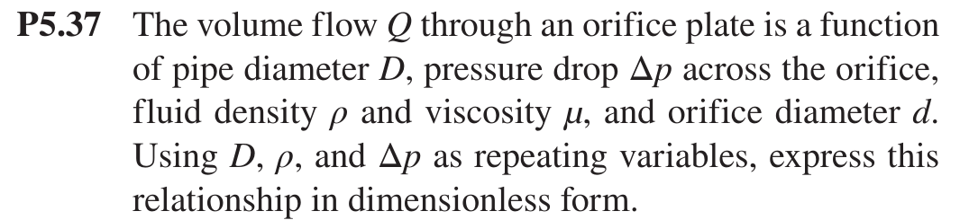

P5.72 · HW due Mon 10/26 · Dimensional analysis (Ch 5)
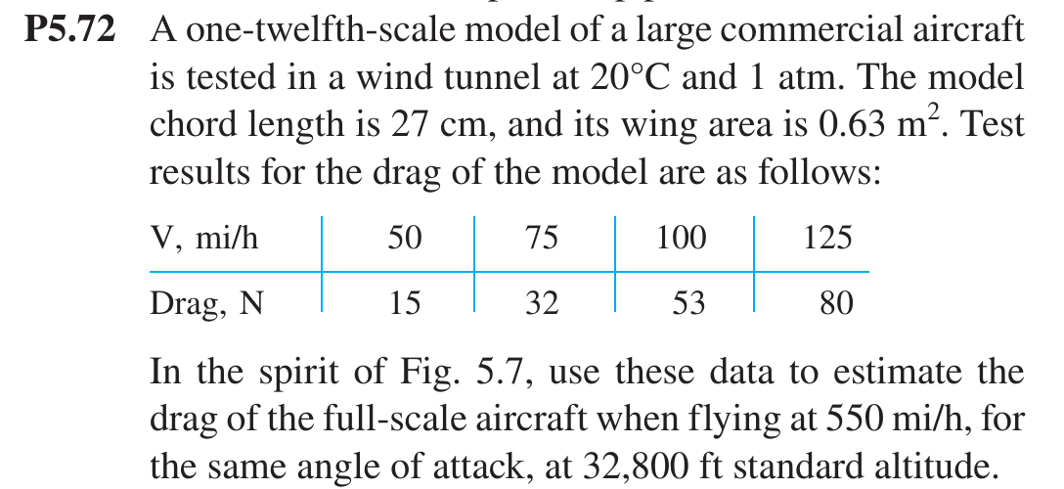

P5.73 · HW due Mon 10/26 · Dimensional analysis (Ch 5)
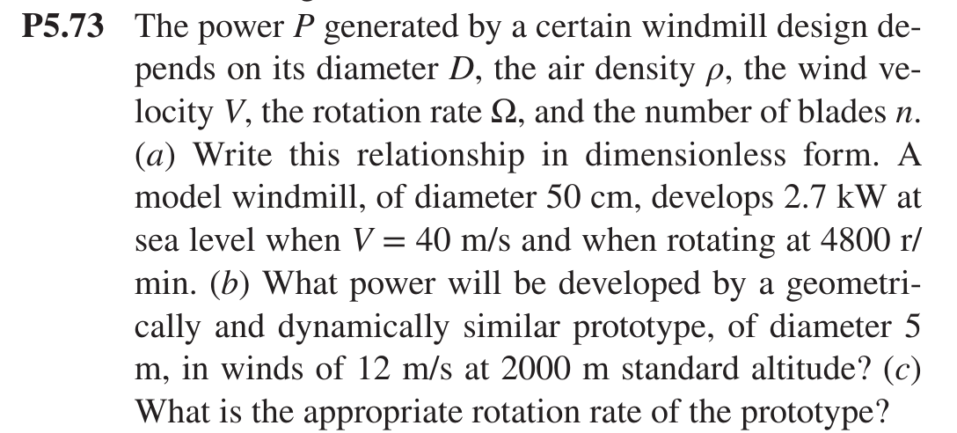

P5.74 · HW due Mon 10/26 · Dimensional analysis (Ch 5)
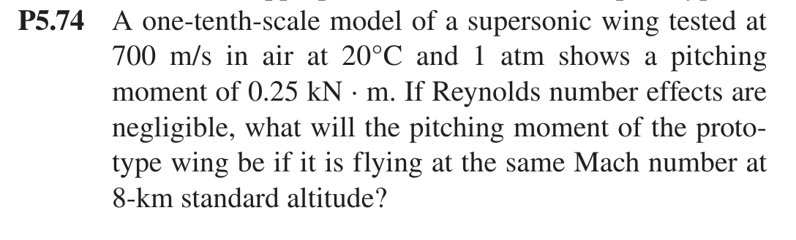

P6.4 · HW due Mon 11/2 · Pipe flow (Ch 6)
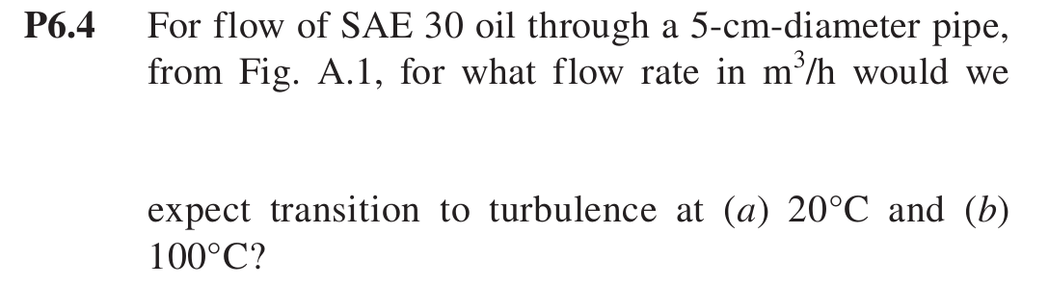

P6.8 · HW due Mon 11/2 · Pipe flow (Ch 6)
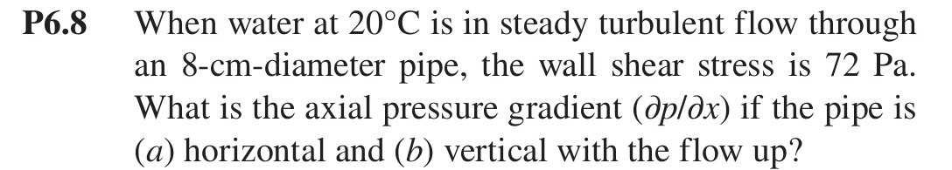

P6.18 · HW due Mon 11/2 · Pipe flow (Ch 6)
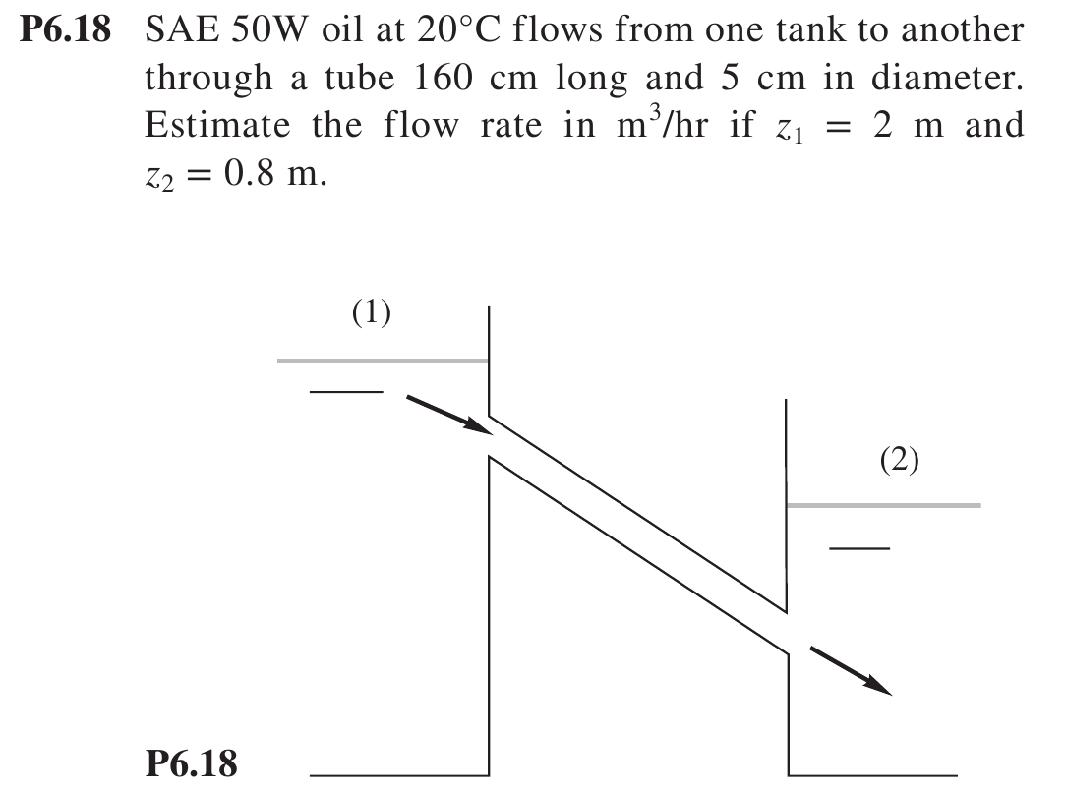

P6.19 · HW due Mon 11/2 · Pipe flow (Ch 6)
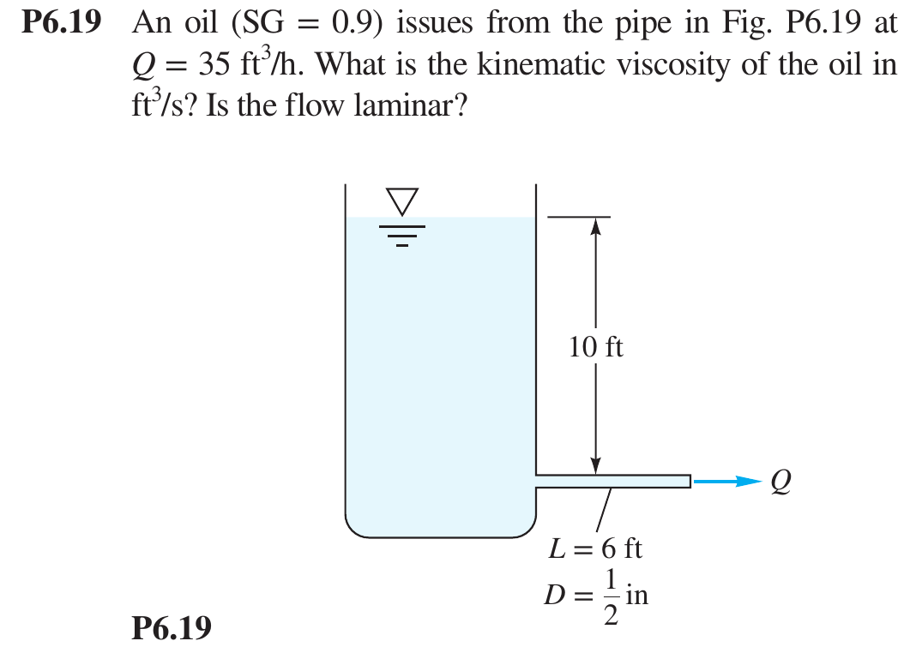

P6.43 · HW due Mon 11/2 · Pipe flow (Ch 6)
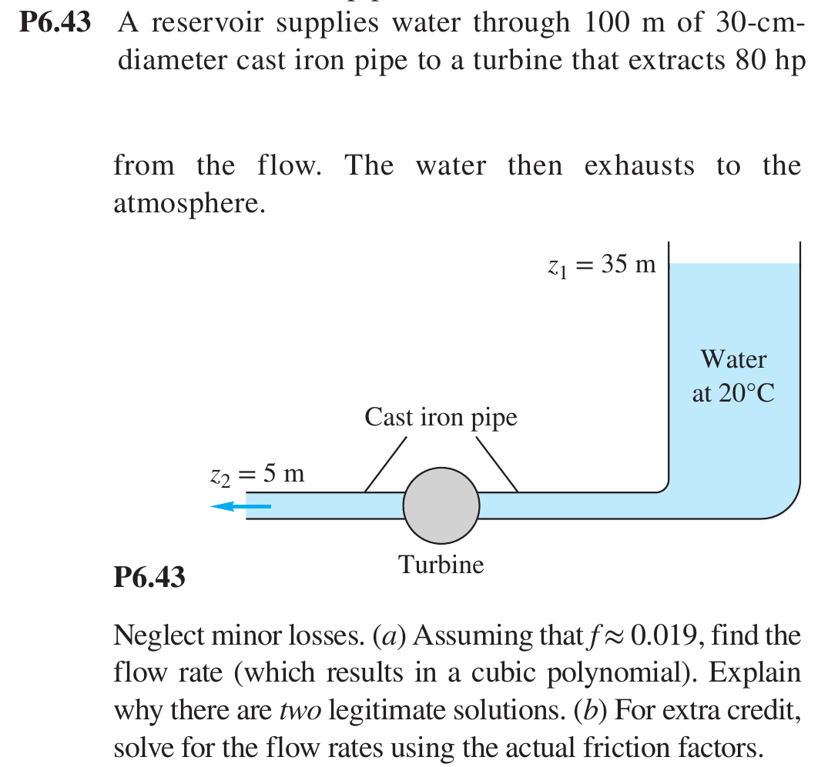

P6.52 · HW due Wed 11/4 · Pipe flow (Ch 6)
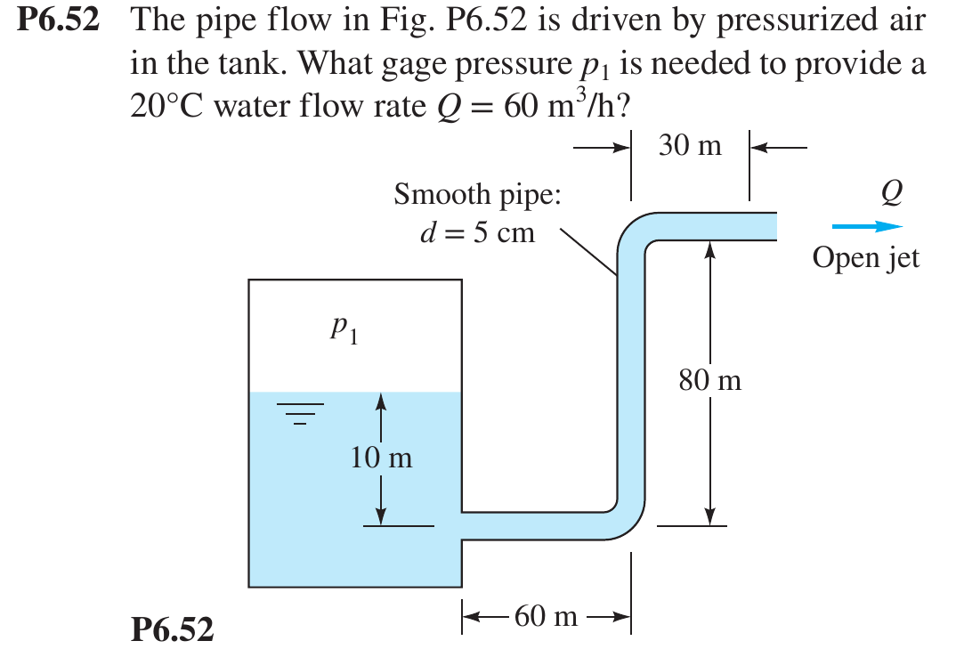

P6.55 · HW due Wed 11/4 · Pipe flow (Ch 6)


